VSI Marketing & Communications Officer (ESC) Role Description 2025

www.vsi.ie

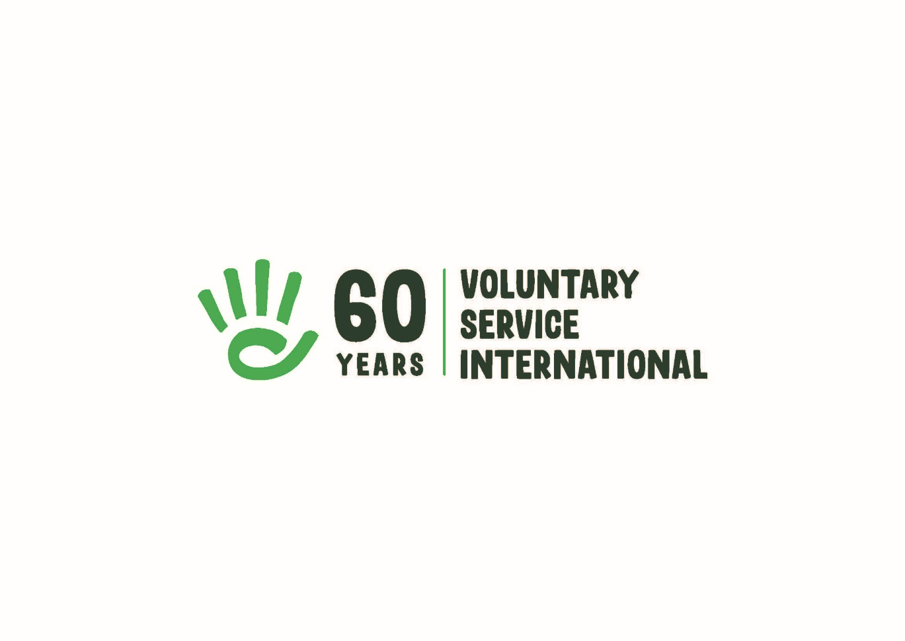

About VSI
Voluntary Service International (VSI) is the Irish branch of Service Civil International (SCI),
a worldwide peace movement founded after the First World War. We are a volunteer-based
movement, founded in 1965 and headquartered in Dublin.

For 60 years we have promoted peace, social justice and sustainable development at
home and abroad through volunteering. By bringing together people from across the globe
to participate in values-based volunteering, we aim to increase awareness and
understanding of the people, the societies and the environment around us. This deeper
understanding will contribute to a global and local society which is more open-minded, aware
and responsible for its own behaviour and actions. We are able to do this with the help of our
network partner organisations at home and abroad, enabling volunteering experiences that
promote peace, social justice and sustainable development.

VSI’s vision is a world of peace, social justice and sustainable development, where all
people live together with mutual respect.

VSI’s mission is to promote a culture of peace, social justice and sustainable development
by organizing and supporting volunteering projects, both in Ireland and internationally.

VSI Values:
Volunteering is at the heart of VSI’s work. We support engagement, without
material reward, that benefits society and aims to achieve positive social change. This is
guided at all times by our core values. Every voluntary project, meeting, exchange or training
reflects these values:
- Non-violence - choosing peaceful resistance and conflict resolution without recourse to
violence as a principle and a method;
- Human Rights - respect for individuals as stated in the Universal Declaration of Human
Rights;
- Solidarity - international solidarity for a more just and equitable world, and solidarity
between all human beings;
- Respect for the Environment - and the ecosystems of which we are a part and upon which
we are dependent;
- Inclusion - being open and inclusive of all individuals without discrimination;
- Empowerment - providing people with knowledge and tools to understand and act to
transform the social, cultural and economic structures that affect their lives at all levels;
- Co-operation - with local communities as well as other local, national and international
partners to strengthen the positive potential within civil society as a whole.

For more information about our organisation, please see:

2021 - 2025 VSI Strategic Plan
2020 VSI Annual Report 2020

ESC Context:
The focus of this ESC position is to promote VSI’s volunteering and non-formal educational
opportunities through both digital technologies and face-to-face communication. The overall
purpose is to encourage participation in VSI’s programmes and to promote engagement with
our core concepts and ideas.

This ESC project offers the volunteer opportunities for personal and social development, to gain skills that can be critical in their professional career and to have an intercultural experience. The participant will gain experience of participating in a national and international NGO. The experience will give the volunteer the opportunity to develop skills in communications and marketing including digital technologies, social media platforms and websites, it will raise the volunteer’s own awareness of our core concepts and ideas and in non-formal education methodologies. The volunteer will meet many young people from different backgrounds as well as people of all generations through for example meeting our national and international volunteers, our members and our partner organizations. The ESC volunteer will be offered opportunities to learn new skills and meet people from different cultures and backgrounds and learn to recognize and develop their own skills and interests.

Role Purpose:
The focus of this ESC position is to promote VSI’s objectives, values and opportunities. To support VSI’s marketing and communications in cooperation with VSI’s team of staff and volunteers. The volunteer will be involved in the promotion of VSI volunteering opportunities and global citizenship education (GCE) programme, maintaining VSI’s social media and website, attending fairs and events, and promoting other VSI events and activities.

Main Tasks:
-Promotion of VSI’s vision of volunteering for peace and our Global Citizenship Education (GCE) programmes, ensuring internal and external visibility of VSI’s work and values:
- Maintain and curate content for VSI’s social media and website promoting VSI’s work, volunteer opportunities, GCE activities and other activities
- Create newsletters and mailings
- Attend volunteer fairs and events
- Deliver info sessions and workshops to raise awareness on VSI’s activities and opportunities

-Maintain and develop VSI’s relationships and communication with members, volunteers, partners and host organisations and other contacts including supporting regular social and networking
activities, in-person and online with VSI volunteers and members.

-Develop and maintain relationships with general marketing targets and intermediaries e.g.
young people, youth organisations, Careers Offices in universities/colleges, libraries, Volunteer Centres, Youth Information Centres.

-Develop and maintain VSI’s photo library/archive.

-Develop communication and advocacy campaigns, resources and materials in line with
VSI’s priorities, values and objectives.

-Working with the VSI Programmes Coordinator and Programmes Officer, research the SCI
and ESC volunteer databases for projects and opportunities matching our values, aims and
priorities.

-Contribute to maintaining and developing VSI’s CRM (Salesforce) in conjunction with staff and other volunteers.

-Develop and maintain a VSI blog and develop new virtual and collaborative platforms (e.g.
Padlet, Miro), in collaboration with the VSI team.

-Research and develop ideas and opportunities for new activities and promoting engagement and participation in them, for example online volunteering and activities.

-Personal Action project:
Possibility to do your own personal action project related to our work and based on your skills and interests (e.g. workshop, exhibition, talks, blog, podcast).

General Tasks (in cooperation with the staff and volunteer team):
-Assisting with other VSI activities e.g. helping to organize the Annual General Meeting.

-Assisting in office related duties with other staff members as appropriate, this includes
answering general enquiries.

-Attending staff and other meetings as appropriate.

-Submitting weekly reports and other reports as required, maintenance of records and files.

Additional Info:
Financial Support
A monthly volunteer allowance of €2,000 (including working from home payment) is provided. Mentoring support for the volunteer’s personal and professional development is also included.

Training:
Training will be provided where appropriate (for example, GDPR, social media, critical literacy skills), this may include international training opportunities and seminars. The volunteer will have an opportunity to participate in an international activity e.g. seminar or training in Europe.

Supervision:
The Marketing and Communications Officer ESC reports to VSI’s Programmes Coordinator (PC) with whom they will work closely and meet regularly. The ESC volunteer will write regular reports as agreed with the PC and VSI CEO.

Hours and Leave:
35 hours per week.
Office hours are from 9.00am – 5.00pm. Some of our activities take place in the evenings and at weekends, time in lieu will be allocated to the volunteer to cover this.
Annual leave for ESC programme volunteers is 24 days annually plus national Irish holidays.

Location:
The VSI Office is located in the Carmichael Centre for Nonprofits, near Smithfield Square, Dublin 7. The VSI team currently work/volunteer hybrid, with some days in the office and others working remotely. Volunteers will be asked to work from the office for a minimum of two days a week and will have the option of remote working on other days. The ESC volunteer will also attend events and activities nationally.

