VSI Programmes Officer (ESC) Role Description 2025

www.vsi.ie

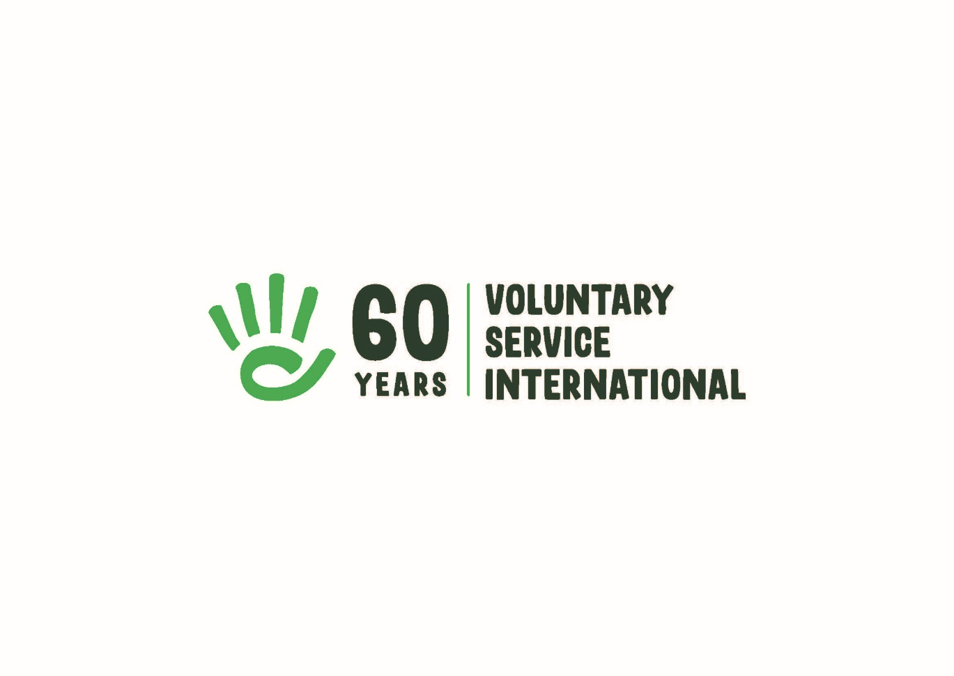

About VSI
Voluntary Service International (VSI) is the Irish branch of Service Civil International (SCI),
a worldwide peace movement founded after the First World War. We are a volunteer-based
movement, founded in 1965 and headquartered in Dublin.

For 60 years we have promoted peace, social justice and sustainable development at
home and abroad through volunteering. By bringing together people from across the globe
to participate in values-based volunteering, we aim to increase awareness and
understanding of the people, the societies and the environment around us. This deeper
understanding will contribute to a global and local society which is more open-minded, aware
and responsible for its own behaviour and actions. We are able to do this with the help of our
network partner organisations at home and abroad, enabling volunteering experiences that
promote peace, social justice and sustainable development.

VSI’s vision is a world of peace, social justice and sustainable development, where all
people live together with mutual respect.

VSI’s mission is to promote a culture of peace, social justice and sustainable development
by organizing and supporting volunteering projects, both in Ireland and internationally.

VSI Values:
Volunteering is at the heart of VSI’s work. We support engagement, without
material reward, that benefits society and aims to achieve positive social change. This is
guided at all times by our core values. Every voluntary project, meeting, exchange or training
reflects these values:
- Non-violence - choosing peaceful resistance and conflict resolution without recourse to
violence as a principle and a method;
- Human Rights - respect for individuals as stated in the Universal Declaration of Human
Rights;
- Solidarity - international solidarity for a more just and equitable world, and solidarity
between all human beings;
- Respect for the Environment - and the ecosystems of which we are a part and upon which
we are dependent;
- Inclusion - being open and inclusive of all individuals without discrimination;
- Empowerment - providing people with knowledge and tools to understand and act to
transform the social, cultural and economic structures that affect their lives at all levels;
- Co-operation - with local communities as well as other local, national and international
partners to strengthen the positive potential within civil society as a whole.

For more information about our organisation, please see:

2021 - 2025 VSI Strategic Plan
2020 VSI Annual Report 2020

ESC Context:
This ESC project offers the volunteer opportunities for personal and social development, to gain skills that can be critical in their professional career and to have an intercultural experience. The participant will gain experience of participating in a national and international NGO. The experience will give the volunteer the opportunity to develop skills in nonformal education methodologies and in delivery of international volunteer projects. It will raise the volunteer’s own awareness of our core concepts and ideas. The volunteer will meet many young people from different backgrounds as well as people of all generations through for example meeting our national and international volunteers, our members and our partner organizations. The ESC volunteer will be offered opportunities to learn new skills and meet people from different cultures and backgrounds and learn to recognize and develop their own skills and interests. This role would suit someone who is interested in working in international relations, development education, international youth work or human rights.

Role Purpose:
The focus of this ESC position is to engage volunteers and participants in understanding and learning about our core concepts and ideas through participation in our programmes. The overall purpose is to support volunteers before, during and following volunteer projects and to support participation in and delivery of VSI’s Global Citizenship Education (GCE) programme.

Main Tasks:
-Supporting the preparation, implementation and evaluation of our volunteer programmes to include processing applications, supporting volunteers through all stages of their involvement with VSI (application, preparation, volunteering projects, evaluation, follow-up and continued engagement).

-Supporting volunteer host organisations pre, during and post projects, which may include visiting the projects nationally.

-Supporting the VSI team to deliver our Global Citizenship Education programme and climate justice project through non-formal educational activities.

-Liaison with VSI’s international branches, partner and host organisations and with national organisations and partners.

-Responding to enquiries regarding VSI’s volunteer programmes (phone, email, social media, in-person).

-Contributing to marketing and communications, including VSI’s social media. This includes attending events, participating in promotional and publicity activities, representing VSI at volunteer fairs etc.

-Personal Action project: Possibility to do your own personal action project related to our work and based on your skills and interests (e.g. workshop, exhibition, talks, blog, podcast).

General Tasks (in cooperation with the staff and volunteer team):
-Assisting with other VSI activities e.g. helping to organize the Annual General Meeting.

-Assisting in office related duties with other staff members as appropriate, this includes
answering general enquiries.

-Attending staff and other meetings as appropriate.

-Submitting weekly reports and other reports as required, maintenance of records and files.

Additional Info:
Financial Support
A monthly volunteer allowance of €2,000 (including working from home payment) is provided. Mentoring support for the volunteer’s personal and professional development is also included.

Training:
Training will be provided where appropriate (for example, GDPR, social media, critical literacy skills), this may include international training opportunities and seminars. The volunteer will have an opportunity to participate in an international activity e.g. seminar or training in Europe.

Supervision:
The Programmes Officer ESC reports to VSI’s Programmes Coordinator (PC) with whom they will work closely and meet regularly. The ESC volunteer will write regular reports as agreed with the PC and VSI CEO.

Hours and Leave:
35 hours per week.
Office hours are from 9.00am – 5.00pm. Some of our activities take place in the evenings and at weekends, time in lieu will be allocated to the volunteer to cover this.

Annual leave for ESC programme volunteers is 24 days annually plus national Irish holidays.

Location:
The VSI Office is located in the Carmichael Centre for Nonprofits, near Smithfield Square, Dublin 7. The VSI team currently work/volunteer hybrid, with some days in the office and others working remotely. Volunteers will be asked to work from the office for a minimum of two days a week and will have the option of remote working on other days. The ESC volunteer will also attend events and activities nationally.

